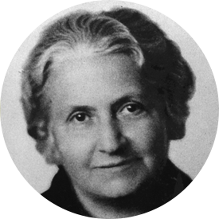  Introduction to Maria Montessori (1870-1952)  Maria Montessori originally qualified as a medical doctor and from this her work lead her into the teaching and education field. First Maria’s work started with children who had learning difficulties and then as her theory was progressing it was then introduced into her normal teaching! Her theory is set as an alternative type of education in which it highlights the child’s natural ability to learn.  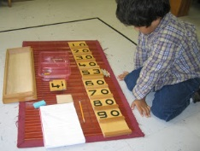 | 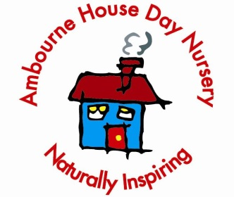  Practical Life  This area is where the children start to develop their independence within an environment. Practical life materials are real life objects that children will be used to seeing; for example introduce transferring water with jugs, spoons etc. Whilst completing this activity it will teach the children respect for their environment  Aims/objectives:  - To develop hand/eye co-ordination  - Encourage independence  - To develop manipulative skills  - Encourage manners and respect  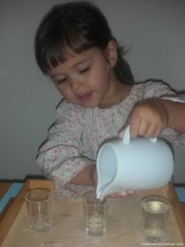
Overview

Montessori is a child led form of education; the materials are specifically designed to meet each of the children’s developmental needs and interests. The children have full access to the Montessori equipment throughout the whole day at their leisure or within a planned activity. The staff at Ambourne House will demonstrate how to use the equipment on a one-to-one basis or within a small group. Once the children have been shown this, they are then free to explore the environment.
The Montessori curriculum is divided into six areas:  - Practical life  - Sensorial  - Language  - Mathematics  - Cultural  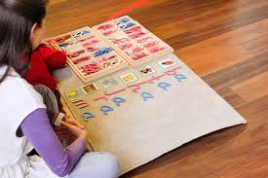  - Creative | Sensorial:  These activities encourage the children to explore with their senses. Colours, shapes, dimensions, smells, sounds and tastes are all introduced with a wide range of activities. We start with the knobbed cylinders as this starts the understanding of size and one-to-one correspondence. Colours and shades are introduced through pairing and grading activities with the colour boxes.  Aim/objectives:  - To develop children’s visual awareness and fine motor skills  - To further the child’s perception of colour and shade  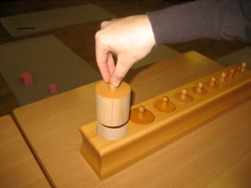  To extend the child’s senses through touch
Language:  This is developed through hands on activities, giving the children concrete experiences which they are able to understand and relate to. Letters are introduced in a physical way through sandpaper letters. This allows the child to feel each letter shape and gain confidence in its formation before moving on to mark making.  Aims/objectives:  - To help the child understand expression  - To be aware of sounds in spoken language  - To introduce reading written symbols  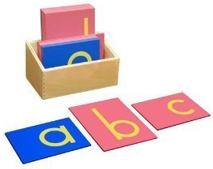  - To introduce children to books as something natural, enjoyable and often useful. | Cultural:  This area explores the environment that we live in; it is divided into geography, botany, biology, history and science. Each area introduces knowledge of our world and encourages the children to decentre. Encouraging them to be respectful and caring towards others and helping to develop empathy towards others.  Aims/objectives:  - To learn different landmark signs  - To help the child differentiate different landmarks near home  - To introduce the idea that life is different in places around the world  - To understand the distinction between past and present
Mathematics:  This area is quite similar to the language activities. They are very hands on and give the child concrete experiences of number, seriation (ordering), addition, subtraction and multiplication. Mathematics begins with number rods, to introduce the child to counting in a concrete form before moving on.  Aims/objectives:  - To help children learn the names of numbers  - To link quantity with a number  - To introduce odd and even  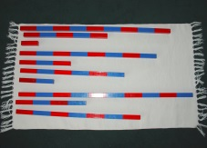  - To develop a child’s memory of numbers | Creative:  During these activities children are able to explore their senses, develop thoughts and ideas and express their feelings. Creative activities consist of painting, dancing, singing and many forms of arts and crafts which you will see children enjoying regardless of the method of education being used.  Aims/objectives:  - Express feelings and emotions  - Enjoyment of movement, sound, colour and sensation  Conclusion  Montessori is a child centred education and through each of these areas the child is able to develop and progress with safety and given the knowledge that they crave and are entitled to!

